Day 9
VALIDATE STACK OPERATION:
CODE:
import java.util.*;
class pushpop{
public static void main(String[] args){
Scanner sc=new Scanner(System.in);
System.out.print("N: ");
int n=sc.nextInt();
System.out.print("Enter the pushed array: ");
int pushed[]=new int[n];
for(int i=0;i<n;i++){
pushed[i]=sc.nextInt();
}
System.out.print("Enter the popped array: ");
int popped[]=new int[n];
for(int i=0;i<n;i++){
popped[i]=sc.nextInt();
}
int index=0;
Stack<Integer> s=new Stack<>();
for(int i=0;i<n;i++){
s.push(pushed[i]);
if(s.peek()==popped[index]){
s.pop();
index++;
}
}
for(int i=index;i<n;i++){
if(s.peek()==popped[index]){
s.pop();
index++;
}
}
if(s.isEmpty()){
System.out.println("True");
}
else{
System.out.println("False");
}
}
}
OUTPUT:
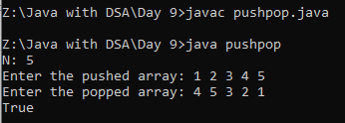
VALIDATE PALINDROME IGNORE SPECIAL CHARACTER:
CODE:
import java.util.*;
class pali{
public static void main(String[] args){
Scanner sc=new Scanner(System.in);
System.out.print("Enter the string: ");
String str=sc.nextLine();
str=str.toLowerCase();
StringBuilder s=new StringBuilder();
for(int i=0;i<str.length();i++){
char ch=str.charAt(i);
if(Character.isLetter(ch)){
s.append(ch);
}
}
Stack<Character> stack=new Stack<>();
for(int i=0;i<s.length();i++){
char ch=s.charAt(i);
stack.push(ch);
}
System.out.println(stack);
for(int i=0;i<s.length();i++){
char ch=s.charAt(i);
if(stack.pop()!=ch){
System.out.print("False");
return;
}
}
if(stack.isEmpty()){
System.out.print("True");
}
}
}
OUTPUT:
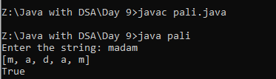
QUEUE OPERATIONS:
CODE:
import java.util.*;
class operation{
public static void main(String[] args){
Queue<Integer> q=new LinkedList<>();
q.add(5);
q.add(12);
q.offer(19);
q.offer(21);
q.add(23);
System.out.println("After Insertion: "+q);
q.remove();
q.poll();
System.out.println("After Remove: "+q);
System.out.println("Element: "+q.peek());
System.out.println("Front Element: "+q.element());
System.out.println("Size: "+q.size());
System.out.println("Contains: "+q.contains(21));
System.out.println("Is Empty?: "+q.isEmpty());
}
}
OUTPUT:
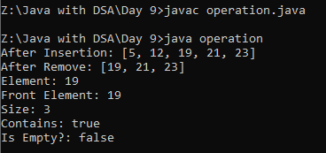

ARRAYDEQUE OPERATIONS:
CODE:
import java.util.*;
import java.util.ArrayDeque;
class op{
public static void main(String[] args){
ArrayDeque<Integer> a=new ArrayDeque<>();
a.addFirst(5);
a.addLast(23);
a.offerFirst(12);
a.offerLast(21);
a.addFirst(19);
a.addLast(521);
a.offerFirst(13);
a.offerLast(14);
System.out.println("After Insertion: "+a);
a.removeFirst();
a.removeLast();
a.pollFirst();
a.pollLast();
System.out.println("After Remove: "+a);
System.out.println("Element: "+a.peekFirst());
System.out.println("Element: "+a.peekLast());
System.out.println("First Element: "+a.getFirst());
System.out.println("Last Element: "+a.getLast());
System.out.println("Size: "+a.size());
System.out.println("Contains: "+a.contains(5));
System.out.println("Is Empty?: "+a.isEmpty());
}
}

OUTPUT:
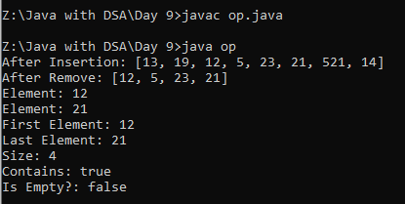
REVERSE THE NUMBERS USING K VALUES:
CODE:
import java.util.*;
import java.util.PriorityQueue;
class reverse{
public static void main(String[] args){
Scanner sc=new Scanner(System.in);
System.out.print("N: ");
int n=sc.nextInt();
System.out.print("Enter an array: ");
int[] arr=new int[n];
for(int i=0;i<n;i++){
arr[i]=sc.nextInt();
}
System.out.print("K: ");
int k=sc.nextInt();
ArrayDeque<Integer> a=new ArrayDeque<>();
for(int i=0;i<k;i++){
a.addFirst(arr[i]);
}
for(int i=k;i<arr.length;i++){
a.addLast(arr[i]);
}
System.out.println(a);
}
}
OUTPUT:
